**Hotel information for Friday and Saturday, April 11-12, 2025**

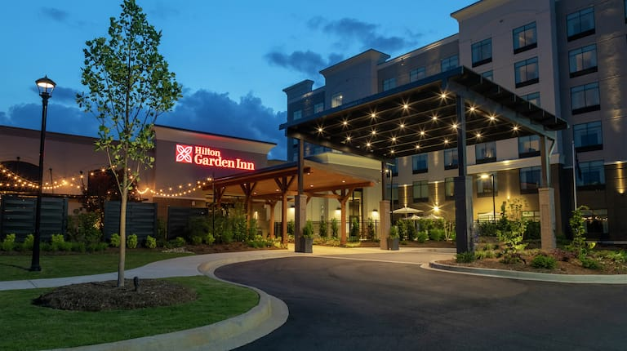

Just off I-26 and US-29 near WestGate Mall, our **Hilton Garden Inn Spartanburg** hotel is conveniently located for your next trip to South Carolina.

**The Hilton Garden Inn Spartanburg**

805 Spartan Boulevard

Spartanburg, SC 29301

**1-864-913-1200**

Room Rates $134.00

**Reservation Code: SCWW**

Check In - 3:00pm… Late Check out 12:00 noon

**Booking Link**: [SC Alliance of Ministers' Wives and Ministers' Widows at Hilton Garden Inn Spartanburg 2025](https://www.hilton.com/en/book/reservation/deeplink/?ctyhocn=GSPSPGI&groupCode=SCWW&arrivaldate=2025-04-11&departuredate=2025-04-12&cid=OM,WW,HILTONLINK,EN,DirectLink&fromId=HILTONLINKDIRECT)

**Booking Code**: SCWW

Guests may also call the hotel directly to book at (864) 913-1200 and request the “**SCWW**” rate for April 11 – 12, 2025. Those who wish to book online using their Hilton Honors account may do so by inputting the rate code “**SCWW**”

under “Special Rates – Group Code.”

Please note that **the cutoff date is set for March 28, 2025**, 2 weeks prior, so everyone would need to book by or before 11:59PM on that day to secure the group rate. Please note that there is a 72 hour/3-day cancellation policy in place for the group.

Breakfast will be included in the rate for up to two (2) guests per room. An additional $5 will be added per person for guest three (3) and guest four (4). Breakfast vouchers will be distributed at check in.